Creation of new Postman request with collection

# Problem Statement:

Create a New Request in Postman and covering the following collections

* GET Request in Postman
* Response in Postman
* Request Parameters in Postman
* POST Request using Postman

## Steps to execute:

Part 1: Use [Star Wars API](https://swapi.co/documentation#intro) link <https://swapi.co/documentation#intro>

1. GET a list of planets.

2. GET a single person object.

Part 2: Use [vschool](https://api.vschool.io/%5byour_name%5d/todo) endpoint <https://api.vschool.io/%5byour_name%5d/todo>

3. GET one id property.

4. DELETE one id property.

5. PUT one id property.

6. Use Postman to POST 3 new objects. Run another GET to see them

# Solution:

Part 1:Use [Star Wars API](https://swapi.co/documentation#intro) link <https://swapi.co/documentation#intro>

This URL is not working.

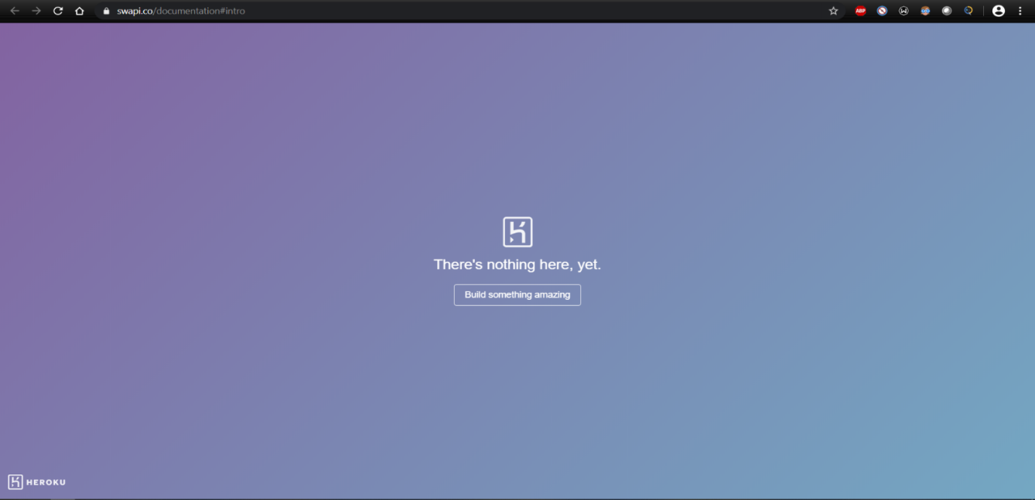

Part 2: **Use**[**vschool**](https://api.vschool.io/%5byour_name%5d/todo)**endpoint**[**https://api.vschool.io/%5byour_name%5d/todo**](https://api.vschool.io/%5byour_name%5d/todo)

1. Created all the required Collections:  
   GET Request in Postman  
   Response in Postman  
   Request Parameters in Postman  
   POST Request using Postman
2. Created a variable “endpoint” in “Vschool” environment to store the endpoint address: <https://api.vschool.io/%5byour_name%5d/todo>.
3. Created a GET request in GET Request in Postman Collection to get server response

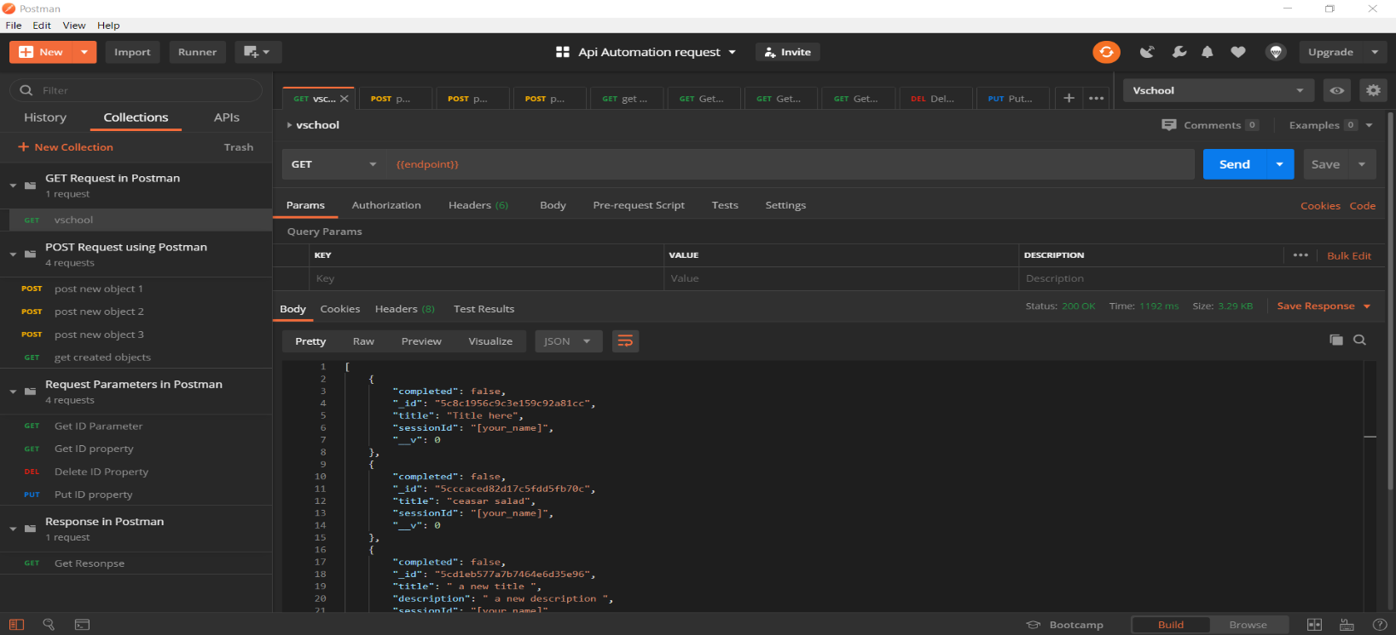

1. **GET one id property.**  
   Created a GET request in Request Parameters in Postmanwith a test case to get any id value from the server response and then saved that id value in “idValue” variable and saved that variable in “Vschool” environment.  
   Test  
   bodyData = JSON.parse(responseBody)  
   id = bodyData[6]._id  
   pm.environment.set("idValue",id)  
   Then created another GET request {{endpoint}}/{{idValue}} to get the ID Property.

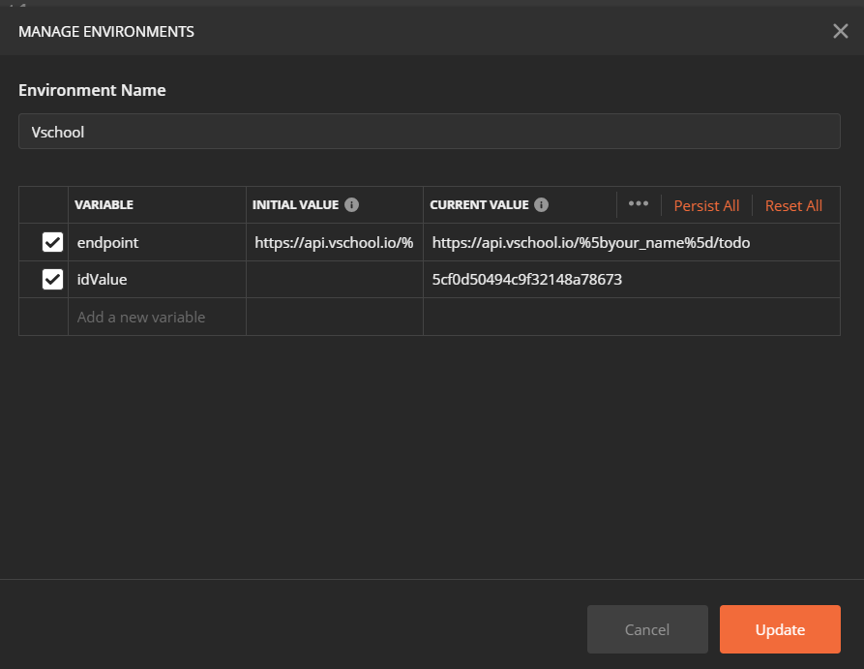

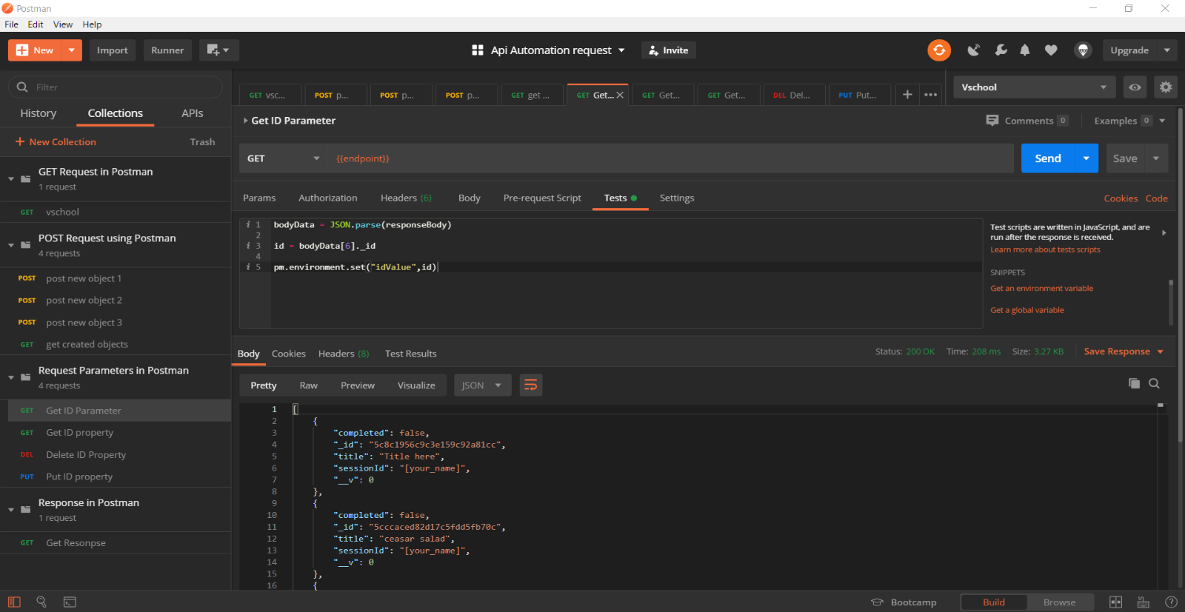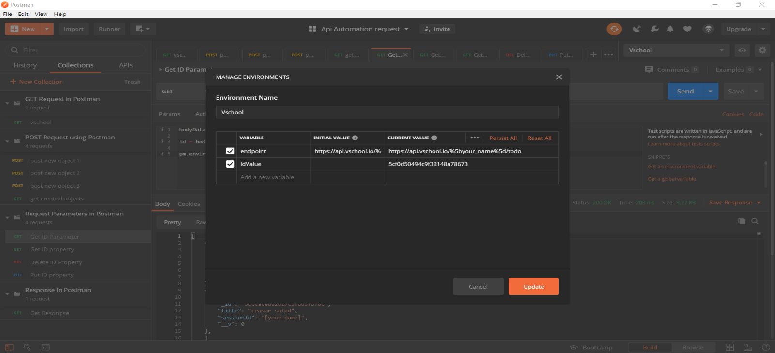

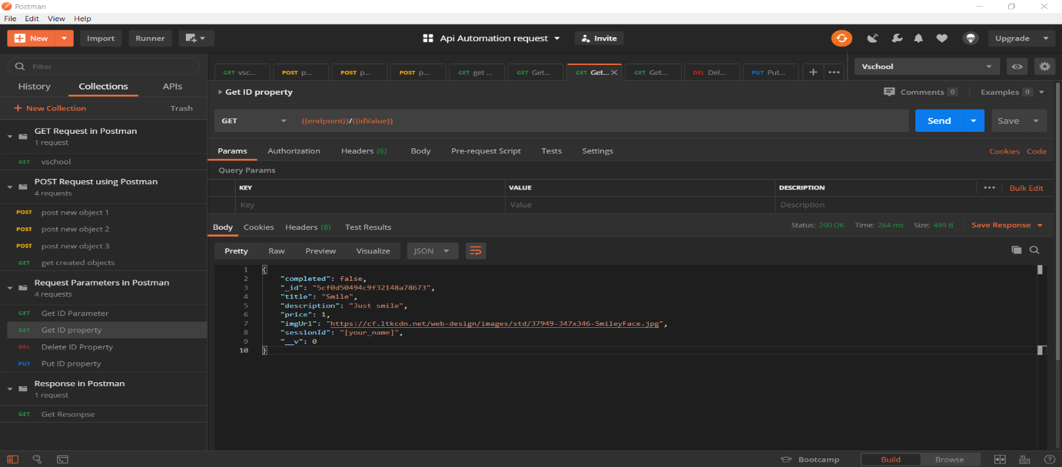

1. **DELETE one id property.**  
   Created a DELETE request in Request Parameters in postman to delete one ID property  
   DELETE {{endpoint}}/5cd30c8e277f9f7d10ba1de3

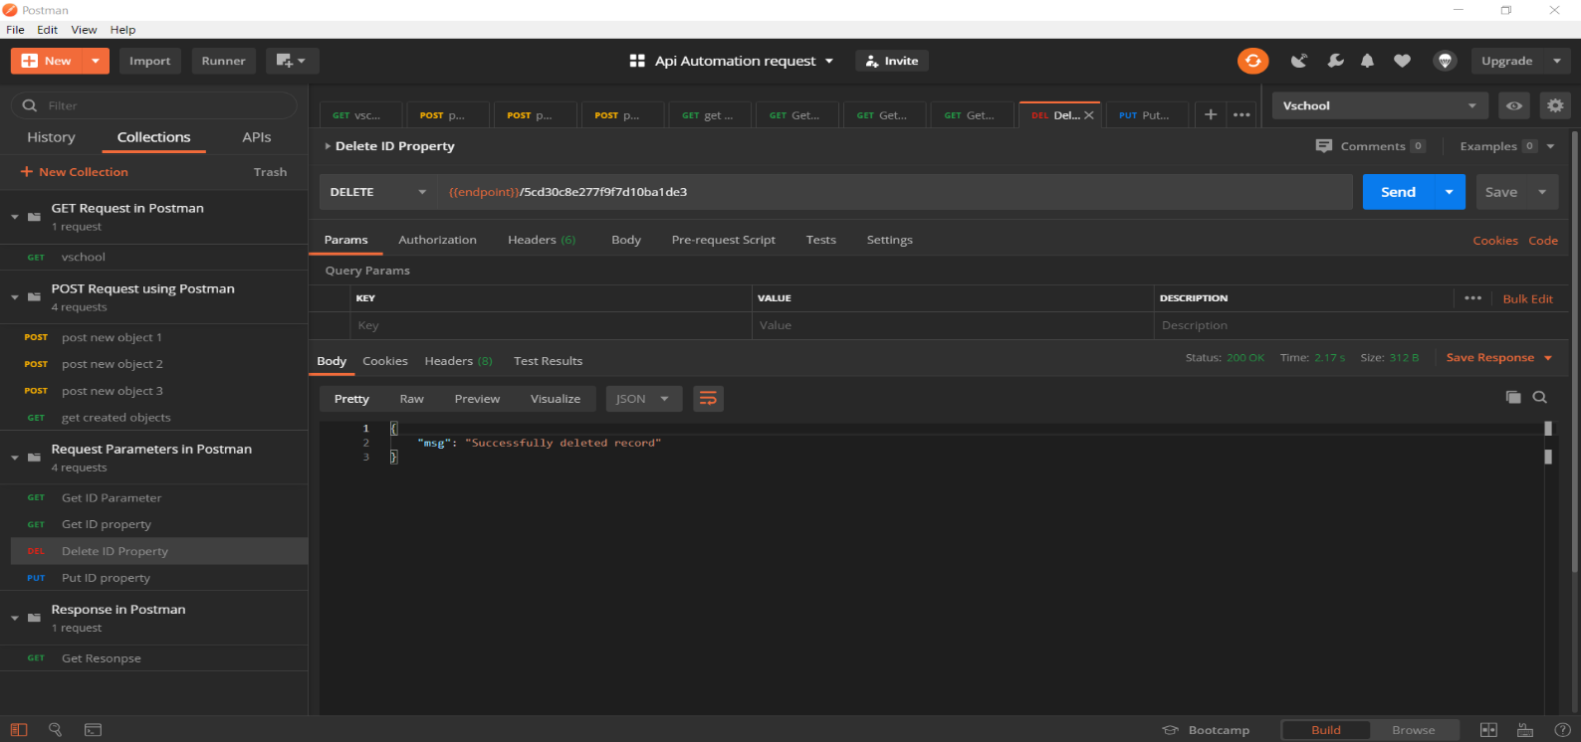

1. **PUT one id property.**  
   It is use to update any record so used it to update the idValue property  
     
   PUT {{endpoint}}/{{idValue}}  
     
   and in body section wrote the values to be updated  
   {  
    "completed": true,  
   "title": "Smile Updated",  
   "description": "Just smile Updated",  
   "price": 10000  
   }

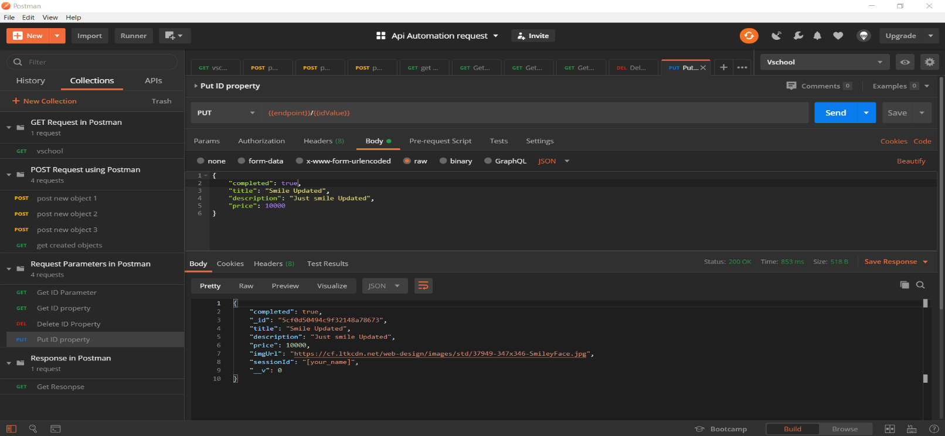

1. **Use Postman to POST 3 new objects.** Run another GET to see them  
   used Post request to post 3 new objects.  
   Template used:  
   {  
   "title": "This is required ",  
   "description": "This is optional ",  
   "price": 0,//must be a number  
   "imgUrl": "http://path-to-url.jpg",  
   "completed": false //must be boolean  
   }  
   This is used in the Body section of the request.
2. Similarly created two more Post requests using same template. 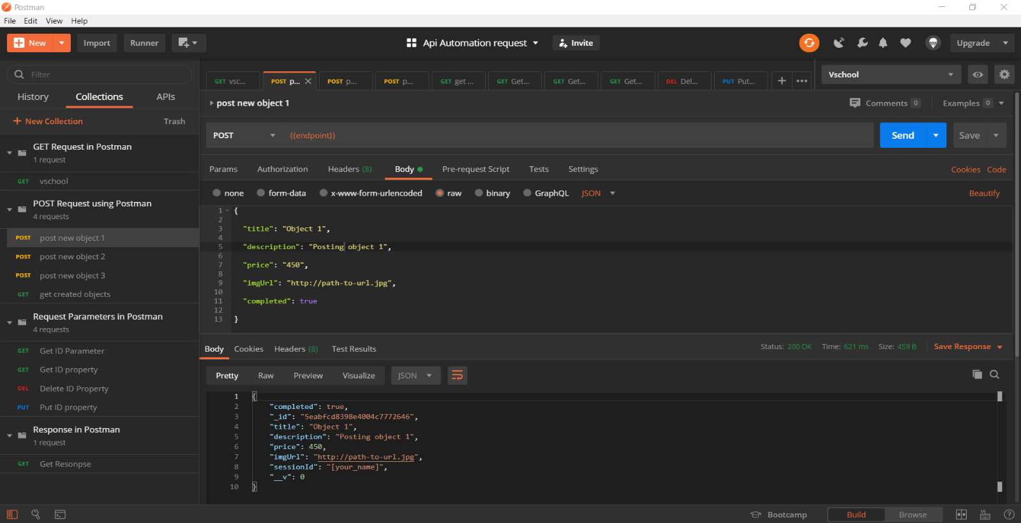

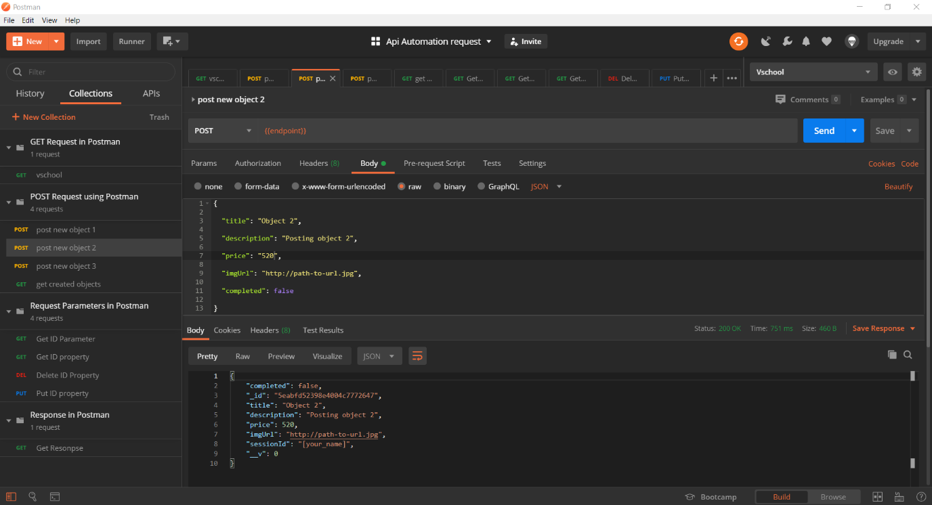

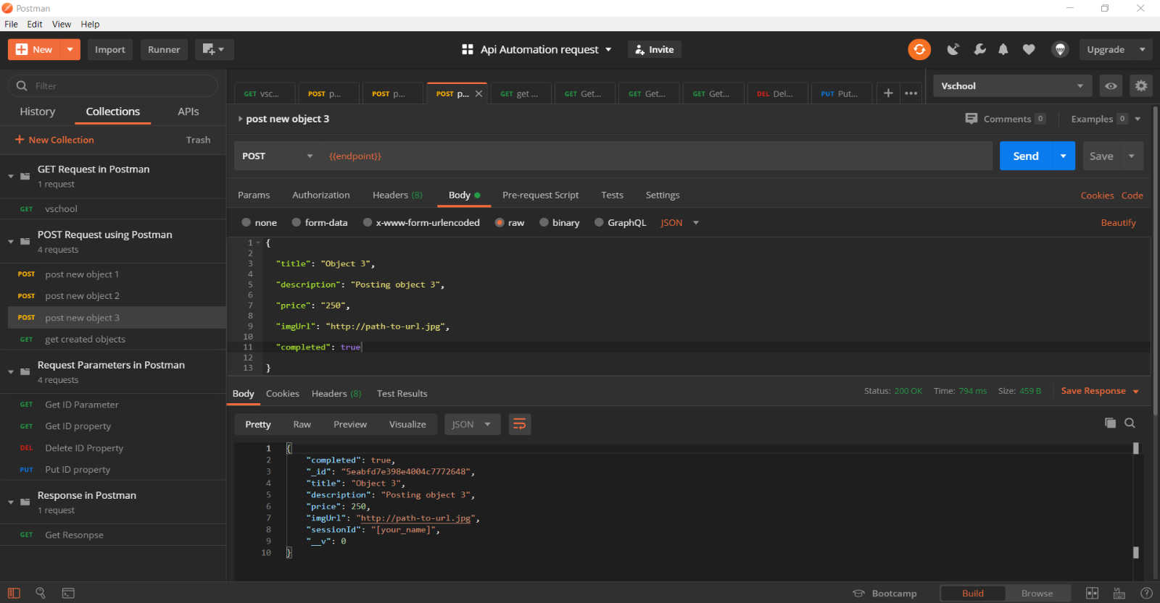

**Used GET request to verify the objects being posted successfully.**

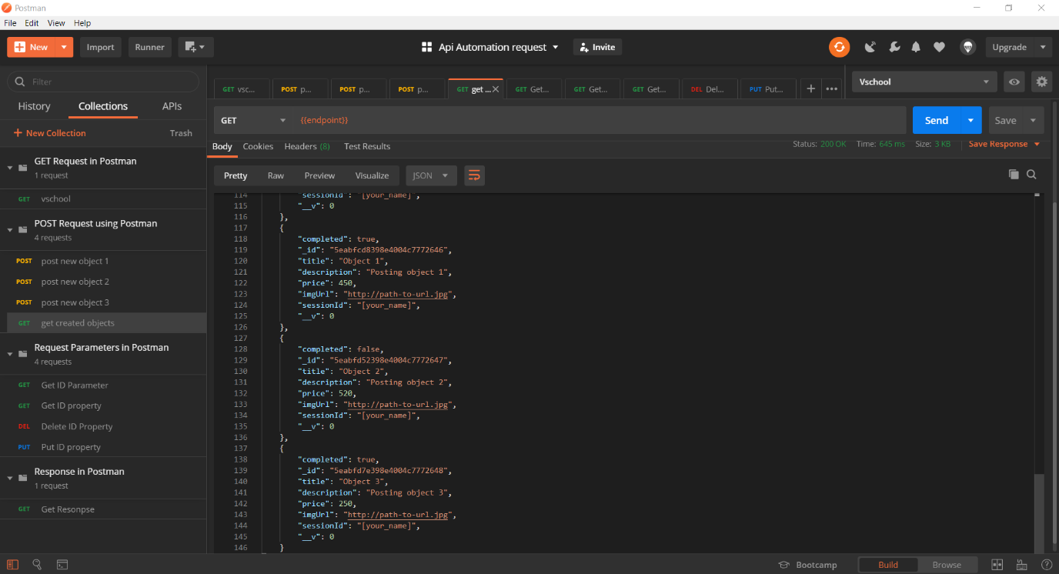

**Postman Console Log**

